St Anne and St Agnes - An Historical Space and its time line

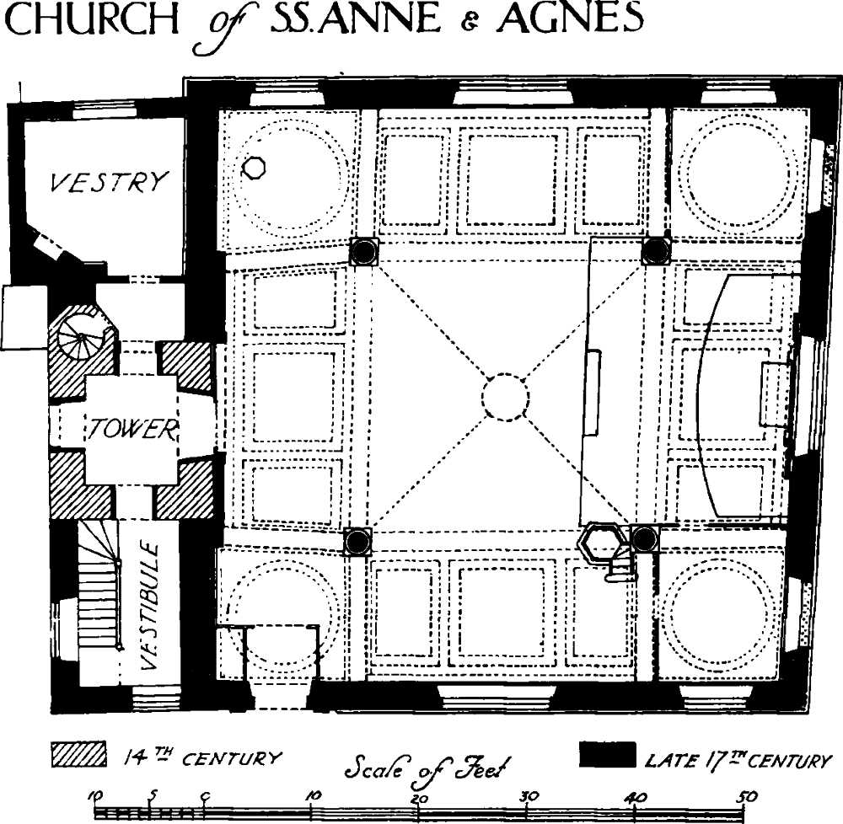
1137 - The church is first mentioned when Goderic Lobbe became a monk here. It lay close to the city wall and to Aldersgate, the ruins of which are still visible today. There was confusion over the name since the church was described variously in Norman records as St Anne-in-the-Willows and as St Agnes. Its unusual double dedication, unique in the City, seems to have been acquired some time in the 15th century.

1548 - A pre-Christmas fire burned the church to the ground and sadly surviving medieval records of St Anne and St Agnes were destroyed. However the earliest remaining dateable stonework in the steeple belongs to the 14th century when many parish churches throughout England extended their towers and added peals of bells to assert their status and sense of local pride.

1666 - The parish had only just recovered from the turbulence of the Civil War when it faced
arguably the two greatest challenges in its history, the Great Plague of 1665 and the
Great Fire of 1666. The devastating effects of the Plague necessitated the digging of a plague pit in the churchyard and less than a year after the Plague subsided, the parish and its church were swept by the Great Fire. St Anne and St Agnes was again destroyed.
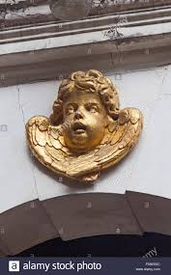
1681 - From 1677 the church was rebuilt by Sir Christopher Wren at a cost of £2448 0s.10d and followed the form of a Greek cross within the outer shell of the walls. This architectural form had been incorporated in Wren’s preferred second design at St Paul’s (expressed eventually in modified form in the Great Model he had made) The church had four central pillars, and assumed the form that it largely retains today, with its weather-boarded cupola and weathervane. We are still greeted by the cherubim in the keystone over the church door and an interior gallery was also provided. Unfortunately, the ring of bells was not replaced, the churchwardens reported that there was only one bell, and there has never been more than that since. The completion of the church had essentially been achieved by 1681 when it reopened for worship.

1780s - it was agreed to purchase an organ and the church was unusual in having a female organist, Mrs Milward.

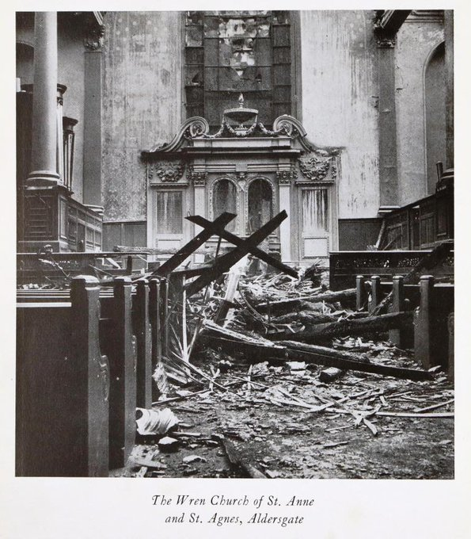
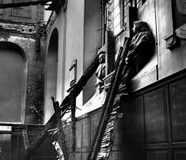
1940 - Then came the destruction of the church for a third time in the Blitz of 1940, along with a swathe of other parish churches around St Paul’s, where the immediate area was devastated. Again, the shell of the church and the tower remained standing. Following the Second World War, the parish was amalgamated with St Vedast-alias-Foster. Extensive restoration followed, using fittings from other City churches.

1950 The church was designated a Grade I listed building on 4 January.

1966 - The church was rededicated and the building was leased for use by Lutheran congregations. A strong musical tradition developed and it became particularly noted for its Bach Vespers.

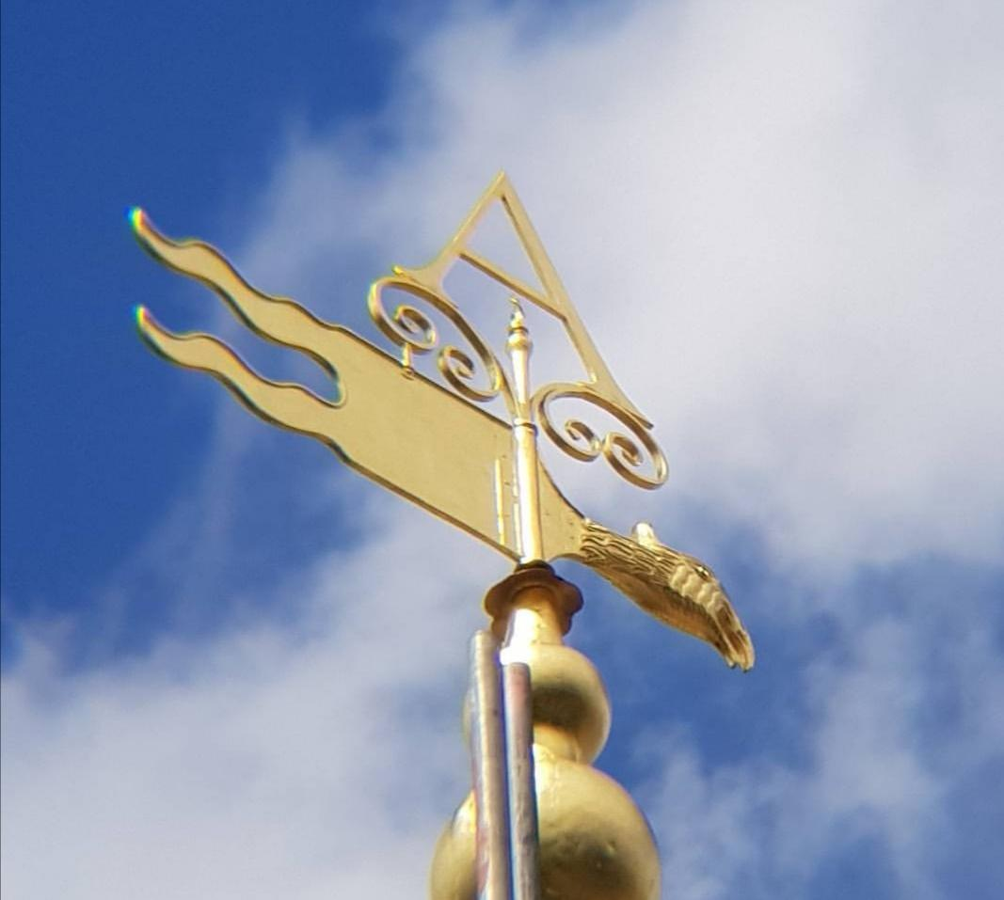
2013 - The Lutherans left and it was leased to our choral music charity, The VOCES8 Foundation, while being reintegrated into the parish life of St Vedast-alias-Foster as a Chapel-of-Ease, which holds services in the church on an occasional basis. The church building has since undergone a significant restoration and refurbishment which includes state of the art lighting, heating, access ramps, loos and doors and the complete refurbishment of its magnificent weather-vane and cupola.

Famous past parishioners have included the poet John Milton, John Bunyan, author of Pilgrim's Progress, and John Wesley, founder of Methodism, who preached twice at the church in 1738.

Sources: The history of St Anne and St Agnes, Gresham Street, London by NW James, Parish Clerk of St Anne and St Agnes in the United Parish of St Vedast-alias-Foster. Full version can be obtained from the church upon request and Wikipeadia. Photo by Sir Cecil Beaton, Plan from British History Online, Cherub by Stiffleaf

